AUGUSTA COUNTY ELECTORAL BOARD
Minutes of Meeting
[July 22, 2025, 10:00am]
Board Conference Room
Augusta County Government Center

Call to Order:
The meeting was called to order at 10:09 am. Present were: Chair; Marcy Reedy,
Secretary; Brenda vonSeldeneck, and Registrar Connie Evans.

Meeting:
Marcy made the motion to go into Closed Session, at 10:00 am “Pursuant to Virginia Code Section 2.2- 3711(A)(1), I move that the Augusta County Electoral Board go into closed session for the purpose of discussing personal matters. In accordance with
Section 2.2-3712(F), the motion was seconded by Brenda. A roll call vote
was call for, with each member voting individually out loud. On returning the meeting to Open Session at 1:10 am, Marcy made the motion, “I Move to reconvene the meeting in open session, and take a roll call vote certifying that to the best of each member’s knowledge (i) only such personnel matters lawfully exempted from open meeting requirements under this chapter and (ii) only such personnel matters as were identified in the motion by which the closed meeting was convened were heard or discussed by the Augusta County Electoral Board.” The motion was seconded by Brenda. A roll call vote was called for, with each member voting
individually out loud.
Next Meeting Scheduled:
August 12, 2025 at 10:00 am
Adjournment:
With no further business, and no public attendance, at 1:15 am, Marcy moved to
adjourn the meeting. Brenda seconded the motion, motion was approved.

Respectfully submitted,

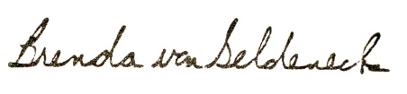

Brenda vonSeldeneck

