

COUNTY OFAUGUSTA
COMMONWEAL TH OF VIRGINIA DEPARTMENT OF COMMUNITY DEVELOPMENT
P.O. BOX 590
COUNTY GOVERNMENT CENTER VERONA, VA 24482-0590

MEMORANDUM

TO: FROM: DATE: SUBJECT:
Augusta County Planning Commission Leslie Tate, Planner II
February 11, 2020 Regular Meeting

The regular meeting of the Augusta County Planning Commission will be held on Tuesday, January 14, 2020 at 7:00 p.m., at the Augusta County Government Center, in the Main Board Meeting Room, 18 Government Center Lane, Verona, Virginia.

The Planning Commission will meet beginning at 4:30 pm in the Board of Supervisors' Conference Room (behind the Board Meeting Room) at the Augusta County Government Center for a staff briefing and to go on viewings. We will have dinner in the Community Development Conference Room at 6:15.

Attached are the agenda and meeting materials for Tuesday's meeting. If you have any questions about any of the material, please feel free to contact me. If you won't be able to attend the meeting, please let Sara or me know as soon as possible.

LT/st

Staunton (540) 245-5700 TOLL FREE NUMBERS
FAX (540) 245-5066
Waynesboro (540) 942-5113







AGENDA

Regular Meeting of the Augusta County Planning Commission Tuesday, February 11, 2020 7:00 P.M.

- CALL TO ORDER

- DETERMINATION OF A QUORUM

- APPROVAL OF THE MINUTES
  - Approval of the Regular and Called Meeting on January 14, 2020

- PUBLIC HEARING

  - A request to rezone from Single Family Residential 10 to General Agriculture approximately 10.5 acres (TMP 85-121) owned by Jason A. and Kimberly D. Almarode and Dylan R. Campbell located on the west side of Mt. Torrey Road (Rt. 664) approximately 0.3 miles south of the intersection of Nursery Road (Rt. 664) and Mt. Torrey Road in Lyndhurst in the South River District. The proposed general use of the property is agriculture. The general use of the property stated in the Comprehensive Plan is Low Density Residential, which may include detached residential units at a density of between one-half and one dwelling unit per acre.

- MATTERS TO BE PRESENTED BY THE PUBLIC

- NEW BUSINESS

a. Resolution for James W. Curd

- OLD BUSINESS

- MATTERS TO BE PRESENTED BY THE COMMISSION

- STAFF REPORTS

  - 2019 Planning Commission Annual Report
  - Information for Commission - Code of Virginia, Section 15.2-2310 (Board of Zoning Appeals Items)

- ADJOURNMENT







COUNTY OF AUGUSTA STAFF REPORT
Jason A. /Kimberly D. Almarode/ Dylan R. Campbell February 11, 2020
Agenda Item# A
Date i=""e b . 11 g0 d o
I

SUMMARY OF REQUEST: A request to rezone from Single Family Residential 10 to General Agriculture approximately 10.5 acres (TMP 85-121) owned by Jason A. and Kimberly D. Almarode and Dylan R. Campbell located on the west side of Mt. Torrey Road (Rt. 664) approximately 0.3 miles south of the intersection of Nursery Road (Rt. 664) and Mt. Torrey Road in Lyndhurst in the South River District. The proposed general use of the property is agriculture. The general use of the property stated in the Comprehensive Plan is Low Density Residential, which may include detached residential units at a density of between one-half and one dwelling unit per acre.
VICINITY ZONING: Single Family Residential 10 zoning to the north, east, and south. General Agriculture zoning to the west.
CURRENT ZONING: Single Family Residential 10 (1962)

COMPREHENSIVE PLAN PLANNING POLICY AREA/FUTURE LAND USE
DESIGNATION: Community Development Area/Low Density Residential

COMMENTS FROM ENGINEER:

Environment Ordinance Considerations

The county has received complaints of standing water between this property and Mt Torrey Rd during periods of high rainfall due to sinkholes on and near this property. Some of these are identified on the attached map. The applicant is advised to consult a geologist to determine the extent of the sink activity and a determination of the suitability of the site for whatever uses are proposed whether or not the property is rezoned. Any required drainage calculations for the sink area must conform to OCR SWM Technical Bulletin #2, "Hydrological Modeling and Design in Karst".

Western portions of this property likely drain toward the South River which is listed on the Virginia DEQ Draft 2018 Impaired Waters List. This impaired segment extends from its confluence with Stony Run downstream to its confluence with the Back Creek. The impaired use is recreation, the specific impairment is E.coli., The sources of the impairment are wildlife other than waterfowl, non-point sources and agriculture. Numerous TMDLs have been approved for this segment for each of the impairments and must be considered by the applicant.

Eastern portions of this property drain to Back Creek which is listed on the Virginia DEQ Draft 2018 Impaired Waters List. This impaired segment extends from the headwaters downstream to its confluence with South River. The impaired uses are aquatic life and recreation, the specific impairment is violations of the general standard for benthics and E. coli. The sources are agriculture, non­ point sources and wildlife other than waterfowl.

Additionally, the Augusta County Comprehensive Plan lists both the South River
- Canada Run and the Back Creek - Inch Branch watersheds as Priority Watersheds for Groundwater Protection due to the presence of karst features and the location of Source Water Assessment Program zones.

Overlay Ordinance Considerations

This property lies outside of the Source Water Protection Overlay (SWPO). This property lies outside of the Airport Overlay District (APO).
This property lies within Zone X on the FEMA FIRM and therefore is outside the Special Flood Hazard Area and not subject to the Floodplain Overlay (FPO) Ordinance.

This property lies outside of the Urban Service Overlay District (USO).

Subdivision Ordinance Considerations

§21-9.1 Subsection B of the County Subdivision Ordinance addresses street layout and access to adjacent property. Development is required to connect to existing or planned streets and must also provide for access to adjacent property that is located with areas designated in the Comprehensive Plan as Urban Service or Community Development Areas. As currently planned and zoned, this property is expected to connect to adjacent undeveloped properties to the north and south.

Natural Resources Recommendations from the Comprehensive Plan

The Augusta County Comprehensive Plan recommends performance standards to protect natural resources. In Community Development Areas, for unique natural features such as caves, major karst features, critical habitats, etc., the Comprehensive Plan recommends to tie these features in with greenways, active and passive recreation areas and flood plain preservation areas.

COMMENTS FROM ZONING ADMINISTRATOR: The property is surrounded by agricultural and residentially zoned property. If the property is rezoned to General

Agriculture, the adjoining Single Family Residential zoned properties could be negatively impacted due to noise, dust, and odor associated with by-right agricultural operations, and Special Use Permits that could be obtained for business uses such as motor vehicle repair, junkyard/salvage yard or dog kennels. Zoning does not feel the request would adversely affect the adjacent parcels currently zoned General Agriculture.

COMMENTS FROM ACSA:

- Water and sewer capacities are not reserved until system adequacy is determined (supply, treatment, transmission) and payment of the connection fees has been received in accordance with Service Authority Policy. Augusta County Service Authority Policies and Procedures can be found at http://www.acsawater.com/oppm.

- Any engineering evaluations and upgrades or extensions would be the responsibility of the owner/developer and are subject to Service Authority review and approval.

- Investigation of available fire flow is recommended to ensure that the system is capable of providing the needed fire flow to comply with Chapter 24 of the Augusta County Code requirements for the proposed use of the property. Any upgrades or extensions would be the responsibility of the owner/developer and are subject to Service Authority review and approval.

- There is an existing 10" waterline along Mt. Torrey Road across from the subject parcel.

- There is no public sewer available in the area of the subject parcel.

COMMENTS FROM HEALTH DEPARTMENT: The health department has no issues with the rezoning request.

COMMENTS FROM FIRE-RESCUE: Fire-Rescue sees little to no impact on service delivery from this request.

TRAFFIC:

Rt. 664 Mt. Torrey Road
-AADT: 2,800 vpd (2018)
-Posted Speed Limit: 35 mph
-K-factor: 0.097; Dir. Factor: 0.577
-Functional Class.: Major Collector

COMMENTS FROM VDOT:

  - The rezoning is not expected to have a substantial impact to existing roadways and would therefore not warrant a Chapter 527 Traffic Impact Analysis. The expected use is farming related activities.
  - Any entrance must be designed and constructed in accordance with VDOT requirements in Appendix F of the Road Design Manual.
    - The existing entrance to Mt. Torrey Road is a private entrance. It has adequate sigh distance; however, the entrance may need to be upgraded to accommodate agricultural related vehicles.

SCHOOL BOARD STAFF COMMENTS: : The request for a change of approximately (10.5) acres from Single Family 10 to General Agriculture will have no significant impact on these three (3) schools.

The table below indicates the enrollment as of December 3, 2019

School | Enrollment | Capacity
Stuarts Draft Elem | 595 | 834
Stuarts Draft Middle | 557 | 960
Stuarts Draft High | 702 | 940

COMMUNITY DEVELOPMENT STAFF COMMENTS:

PROS
- Request is compatible with adjacent General Agriculture zoning to the west.
- With the presence of standing water during high rainfall events, this parcel may not be suitable for residential development.

CONS
- Request is not in compliance with the Augusta County Comprehensive Plan Future Land Use Map which designates the property for future low density residential development.
- Request may not be compatible with adjacent Single Family Residential 10 zoning to the north, east, and south of the subject parcel.
- An agricultural operation, with significant animal waste, may have a negative impact on water resources due to the underlying geology of the property.

COMMUNITY DEVELOPMENT STAFF RECOMMENDATION: The applicant
has indicated that they may want to have a small swine operation; however, if rezoned to General Agriculture, they could have any type of agricultural use, which may have a significant impact on the adjacent property owners zoned Single Family Residential.

The applicant has also indicated that the reason for the rezoning is to permit the construction of a barn, for storage of equipment, prior to an established primary dwelling structure. In order to construct a barn, prior to establishing a principal dwelling, the applicant will need to be farming the property in order to establish the agricultural use and the structure will need to be used to store farm equipment, not equipment for personal/recreational use and/or any off-site business.

Regardless of the reason for requesting the rezoning, staff does not recommend approval as the area has developed residentially and is planned for low-density residential development. If the property owner was interested in some type of small-scale, minimally impactful agriculture use, then they could apply for a Special Use Permit for limited agriculture; although, such permit specifically precludes poultry and swine.

Staff recognizes the desire of the landowner to have their land zoned in such a way that affords them the most flexibility and range of permit options, but staff feels that the request could have negative impacts on surrounding property zoned residentially since 1962.



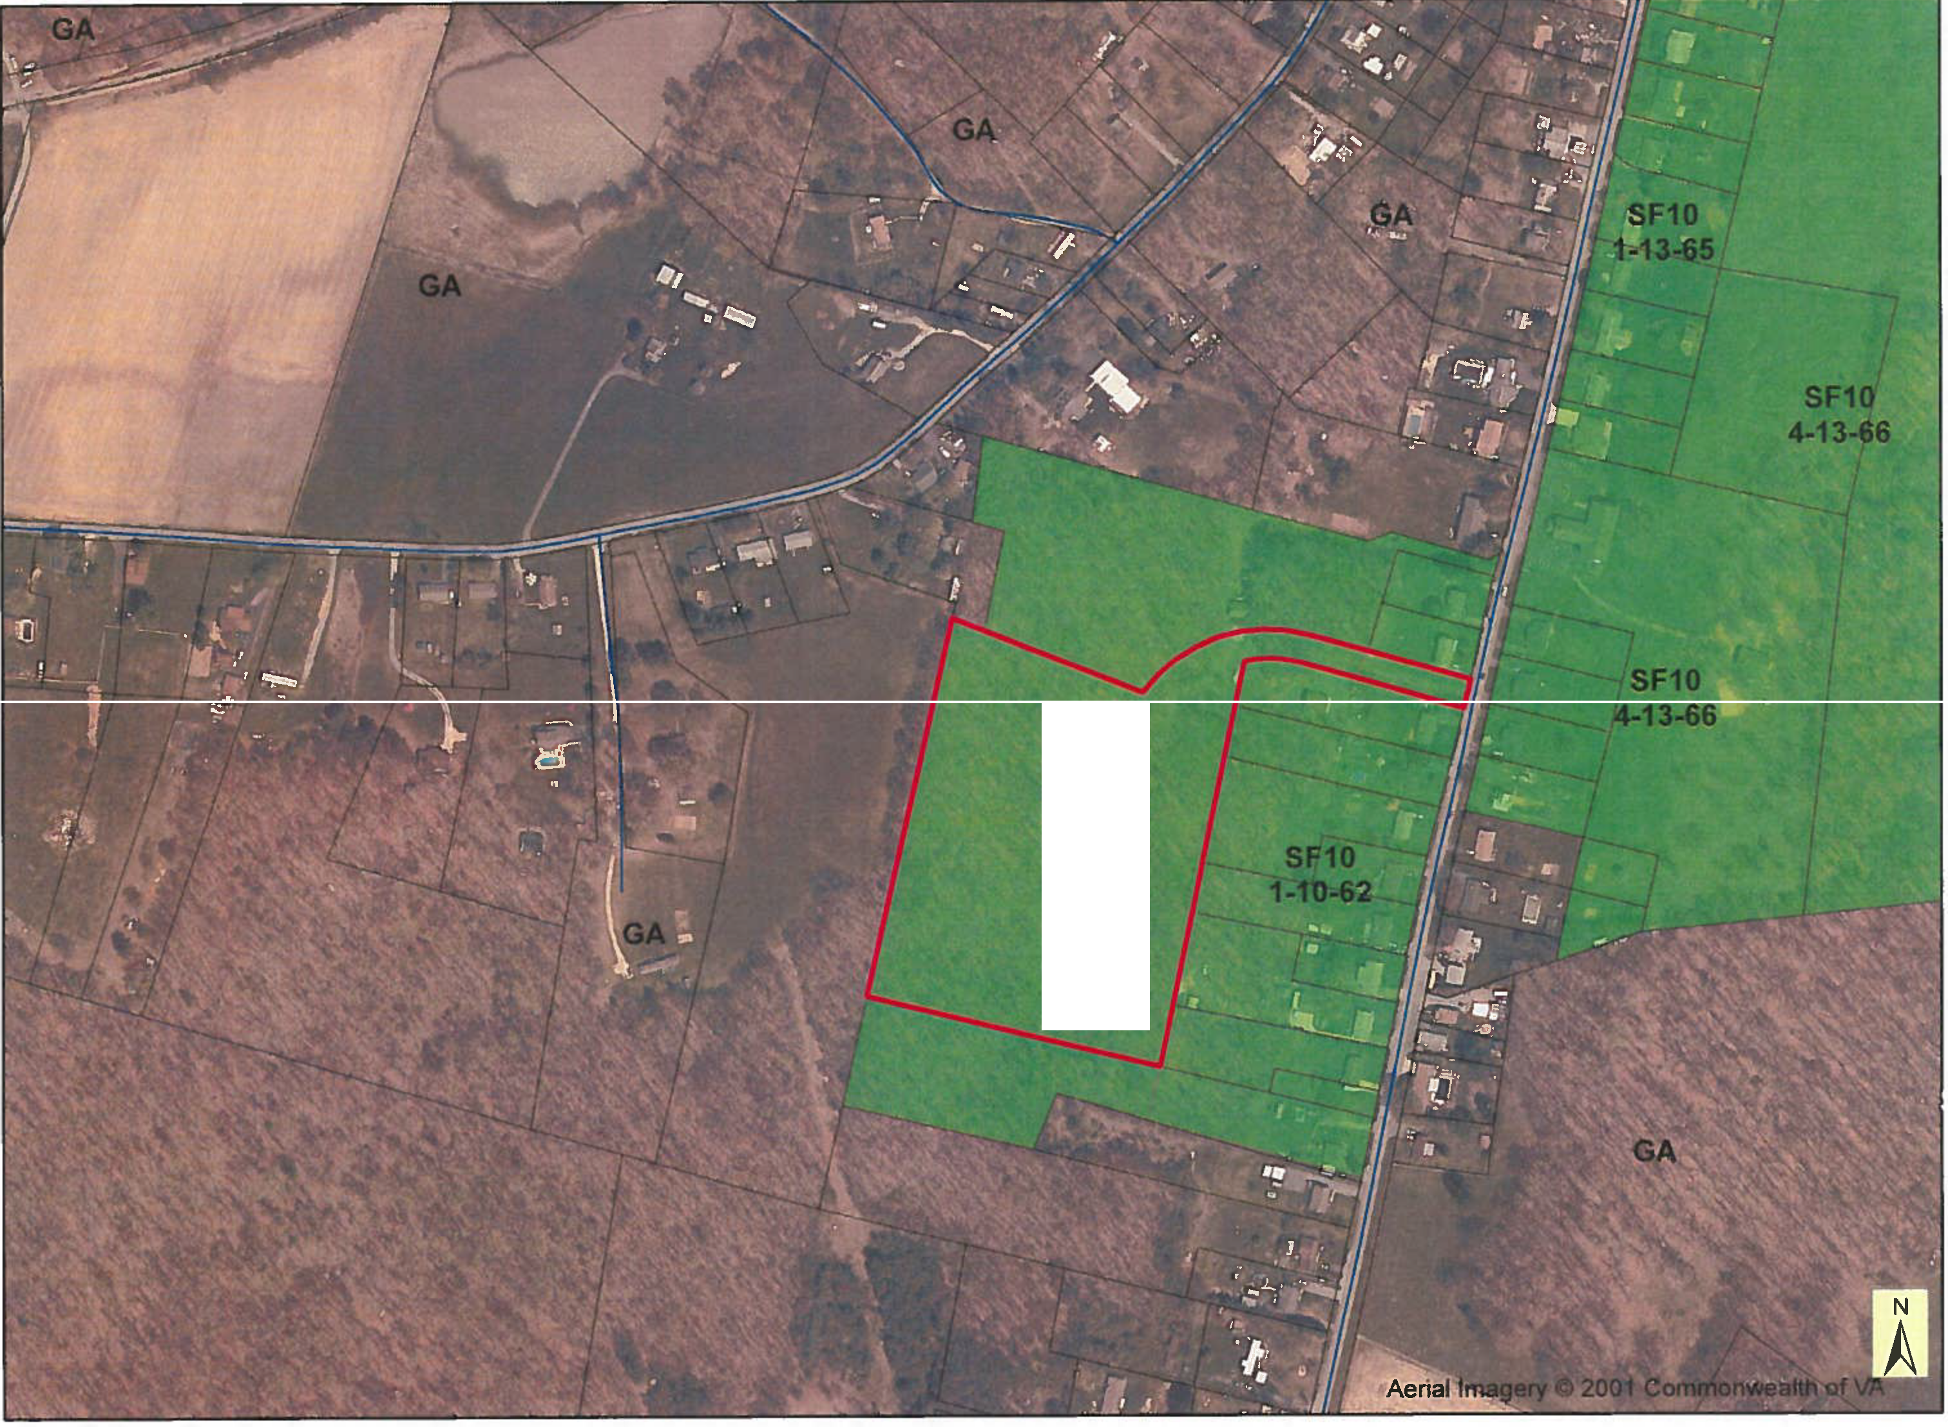Almarode Property

SF10 1-10-62







Agenda Item# 9 A
Date Eeb· II :;k) g.O

AUGUSTA COUNTY PLANNING COMMISSION



ANNUAL REPORT 2019

AUGUSTA COUNTY PLANNING COMMISSION 2019 ANNUAL REPORT

MEMBERSHIP

The Augusta County Planning Commission 2019 commissioners were: E. Thomas Jennings, Jr., Chair; Gregory W. Campbell, Vice-Chair, James W. Curd; Kitra A. Shiflett; Gordon Kyle Leonard, Jr.; Stephen Neil Bridge; and Larry Howdyshell. Leslie C. Tate served as Secretary to the Commission.

MEETINGS

In 2019, the Planning Commission held ten (10) regular meetings. The Commission had strong attendance at all of their meetings with Steve Bridge attending all ten meetings. Greg Campbell, Kitra Shifflett and Larry Howdyshell missed only one meeting. The Commission continued their practice of meeting on the second Tuesday of each month and viewing the rezoning requests prior to the public hearings.

WORKLOAD

The Commission had five (5) rezoning requests come before them, four (4) Comprehensive Plan amendment requests, two (2) proffer condition amendment requests, and a 15.2-2232 Virginia State Code review of a utility scale solar facility for substantial accord with the Comprehensive Plan.

Two of the four Comprehensive Plan amendment requests were related to the Stuarts Draft Small Area Plan. Another Comprehensive Plan amendment request, initiated by the Board of Supervisors, was related to the completion of the East Stuarts Draft Sewer Feasibility Study- Phase I. The remaining Comprehensive Plan amendment was initiated by a landowner request for making the placement of a conservation easement in compliance with the Comprehensive Plan.

The Planning Commission appointed Mr. Bridge to serve as the Planning Commission liaison on a Board appointed committee to address utility scale solar, and potential other renewable energy sources, within the Comprehensive Plan.

The Commission also considered fifteen (15) Zoning and Subdivision Ordinance amendments, representing only a slight decrease from the seventeen (17) amendments heard in 2018.

REZONING OF LAND

Four (4) of the five (5) requests for rezoning were recommended to the Board to be approved, while a request to rezone from General Agriculture to Rural Residential was recommended to the Board for denial based on the area not meeting fire flow

2

requirements of County Code. Table 1 shows a breakdown of the Planning Commission's actions on all the requests for rezoning by magisterial district.

TABLE 1
RECOMMENDATIONS ON REQUESTS FOR REZONING BY THE PLANNING COMMISSION
BY MAGISTERIAL DISTRICT

DISTRICT | RECOMMEND APPROVAL | RECOMMEND DENIAL | TABLED | TOTAL
Beverley Manor | 0 | 0 | 0 | 0
Middle River | 1 | 0 | 0 | 1
North River | 0 | 0 | 0 | 0
Pastures | 0 | 1 | 0 | 1
Riverheads | 0 | 0 | 0 | 0
South River | 1 | 0 | 0 | 1
Wayne | 2 | 0 | 0 | 2
TOTAL | 0 | 0 | 0 | 5

The number of rezoning requests in 2019, five (5), was a decrease from the nine
(9) requests heard in 2018. For the purposes of this report, only the rezoning requests will be considered, not the proffer condition amendments, or Comprehensive Plan amendments. The Board of Supervisors followed the recommendations of the Planning Commission in all of the rezoning cases in 2019.

The acreage recommended for rezoning decreased significantly compared to last year, from approximately 199.9 acres in 2018 to approximately 45.08 acres in 2019 (number does not reflect the approx. 33 acre request that was recommended for denial). Figure 1 below shows the acres recommended for rezoning from 2008 to 2019.

3

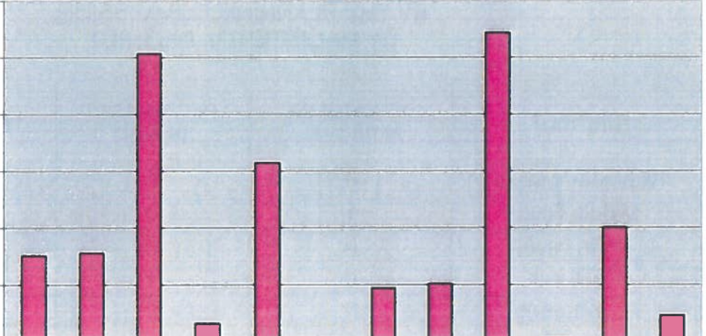
g · I g •• 1 W::::' I - 9 I
2013 2014 2015 2016 2017 2018 2019
Year
2008 2009 2010 2011 2012
E I
200

100

Q C· I .. I I I I
i:t::
G)
u
300
u E
c( 0
UI C
.G_l Ea,
500

400
,,
,G,)
600
Figure 1
Acreage Recommended for Rezoning 2008-2019

- Note: This table does not include requests to add the Public Use Overlay or requests to add or amend and restate proffers.

As shown in Figure 1 above, the acreage recommended for rezoning in 2018 was a notable increase, despite 2016, since 2013. The unique increase in 2016 was mostly attributable to one request to rezone approximately 515 acres from General Agriculture to General Industrial with a portion to Airport Business at the recommendation of the Board of Supervisors. However, 2019 saw another dip in the acreage recommended for rezoning from approximately 200 acres in 2018 to less than 50 acres in 2019.

The rezoning requests in 2019 were distributed over four (4) of the seven (7) magisterial districts. The Wayne District had two (2) requests. The South River, Pastures, and Middle River districts each had one (1) request. There were no rezoning requests made in Beverley Manor, North River or Riverheads districts in 2019. Figure 2 below graphically depicts the number of rezoning requests by magisterial district.

4

Figure 2
Rezoning Requests by Magisterial District
l ■ s everley Manor I .

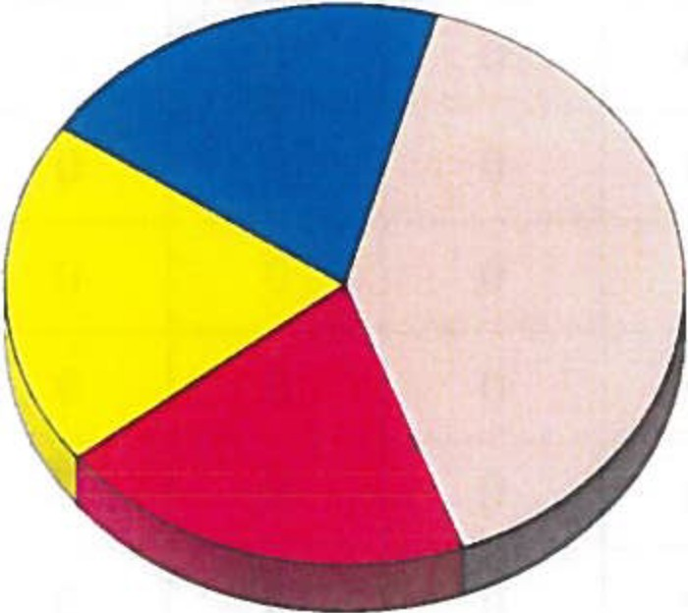
Middle River I I
□North River I I

□Pastures
  - Riverheads
  - South River

I L
'----
□Wayne I I

*Note: This table does not include requests for proffer condition amendments.

Approximately 87% of the land recommended for rezoning in 2019 was from General Agriculture. In addition, 5.97 acres, representing approximately 13% of land recommended for rezoning, was recommended for rezoning from Single Family Residential to General Business (4.6 acres) and Multi-Family Residential (1.37 acres). Table 2 lists the acres recommended for rezoning by zoning classification and magisterial district.

TABLE 2
ACREAGE RECOMMENDED FOR REZONING
BY ZONING CLASSIFICATION AND MAGISTERIAL DISTRICT

ZONE | Beverley Manor | Middle River | North River | Pastures | R'heads | South River | Wayne | TOTAL
General Aariculture | 0 | 37.46 | 0 | 0 | 0 | 1.65 | 0 | 39.11
Rural Residential | 0 | 0 | 0 | 0 | 0 | 0 | 0 | 0
Single-family Residential | 0 | 0 | 0 | 0 | 0 | 0 | 5.97 | 5.97
Attached Residential- Duplexes and Townhouses | 0 | 0 | 0 | 0 | 0 | 0 | 0 | 0
Manufactured Home Park | 0 | 0 | 0 | 0 | 0 | 0 | 0 | 0

5

ZONE | Beverley Manor | Middle River | North River | Pastures | R'heads | South River | Wayne | TOTAL
Multi-family Residential | 0 | 0 | 0 | 0 | 0 | 0 | 0 | 0
Airport Business | 0 | 0 | 0 | 0 | 0 | 0 | 0 | 0
Limited Business | 0 | 0 | 0 | 0 | 0 | 0 | 0 | 0
General Business | 0 | 0 | 0 | 0 | 0 | 0 | 0 | 0
Planned Commerce | 0 | 0 | 0 | 0 | 0 | 0 | 0 | 0
General Industrial | 0 | 0 | 0 | 0 | 0 | 0 | 0 | 0
Planned Unit Developments | 0 | 0 | 0 | 0 | 0 | 0 | 0 | 0
TOTAL* | 0 | 37.46 | 0 | 0 | 0 | 1.65 | 5.97 | 45.08
* Note: This table does not include proffer condition amendment requests or rezoning requests not recommended for approval by the Commission.

Figure 3 graphically illustrates the geographic location of the acreage recommended for rezoning. The Middle River District had approximately 83% of the acres recommended for rezoning (although proffered conditions limited the development to 10 dwelling units), while the Wayne District had approximately 13.3% and the South River had approximately 3.7%.

6

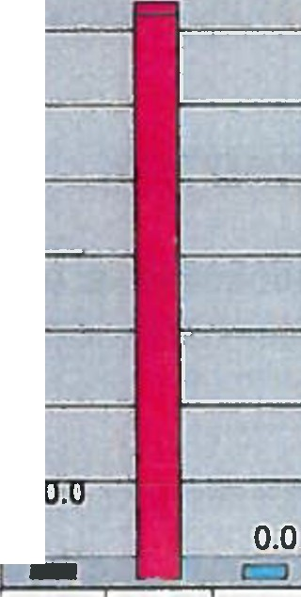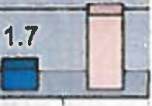
Figure 3
Acreage Recommended for Rezoning by District
..
ecan
Cl)

Cl)
40.0
35.0
30.0
25.0
20.0
15.0
10.0
5.0
0.0
::-
37.5

6.0
0.0 0.0
c:::J -
-----
- Beverley Manor
- Middle River
o North River
□Pastures
Riverheads
- South River
□Wayne
,:,.0
_-t,..'t><:'o-<.. , &
04. . b·sl
0<..
.,:,.flfi... 0":, r,,,."t:.:, .
,:,f.lfi...
f::'-0
. ---------------
o
£:S-
0
, . 0 §
'?o
r,'l>Cj ;s-e
-'
*Note: This table does not include proffer condition amendment requests.

RELATIONSHIP TO THE COMPREHENSIVE PLAN

One of the goals of the Augusta County Comprehensive Plan, affirmed by the Update 2014/2015, is to target the County's growth to those areas with the public services designed to accommodate the development. The Plan recommends that 80% of the County's future residential growth be located in the Urban Service Areas, while Community Development Areas are planned to accommodate up to 10% of the future residential growth. Rural Conservation Areas and Agricultural Conservation Areas are each expected to accommodate less than 5% of the future residential development, with Rural Conservation Areas expected to accommodate the majority of the rural residential development in the County.

One way to track how well the Comprehensive Plan is being implemented is to view the number of rezonings being sought by Comprehensive Plan Planning Policy Area. In 2019, four (4) of the five (5) requests for rezoning were in the Urban Service or Community Development Areas, totaling approximately 40.62 acres. This number includes the 33 acre request to rezone property from General Agriculture to Rural Residential that was denied by the Board of Supervisors for lack of adequate fire flow.

Of the approved rezoning requests, one was located outside of either an Urban Service Area or a Community Development area, in a Rural Conservation Area. This request was approved as a small, incremental addition to an existing manufactured home park with proffers limiting the development to 10 additional units.

7

Of the land being recommended for rezoning out of General Agriculture, 1.65 acres was requested to be rezoned for business development and 37.46 was for residential development. The remaining approximately 5.97 acres was requested to be rezoned from Single Family Residential to General Business or Multi-Family Residential.

ORDINANCE AMENDMENTS

In 2019, ordinance amendments continued to encompass a significant portion of the Planning Commission's workload. The Commission considered fifteen (15) Zoning and Subdivision Ordinance amendments including:

- Reduction in individual sign sizes with waiver provisions and prohibiting sound emitting signs
- Creating a provision for administrative permits in Single Family Residential and Rural Residential for the sale of guns requiring a Type 1 or Type 3 Federal Firearms License
- Clarifying Board of Supervisors Authority to reserve the right to issue Special Use Permits
- Amend age of adult dog from six months to four months
- Reflect a change in the Augusta County Service Authority policy regarding reservation of capacity fees
- Clarification that one-time existing dwelling division does not include mobile or manufactured homes
- Remove waiver provision by Zoning Administrator for reduced parking requirements
- Add definition of limited outdoor storage for application throughout the zoning ordinance
- Amend the definition of a mobile home for accuracy
- Remove percentage/size regulations for attached accessory dwellings that do not change the footprint of the structure
- Permit a facility operator or manager to operate a short-term rental, bed and breakfast, vacation rental
- Remove reference to private schools as an administrative permit in General Business
- Add walk-in freezers and generators as accessory to business when screened and accessory to industrial establishments
- Amend Manufactured Home Subdivision ordinance to permit single family dwellings that are not classified as manufactured homes
- Permit the Board of Zoning Appeals to reduce the 100 ft. setback standard for batching plants for asphalt, cement or concrete in industrial districts.

The Board of Supervisors approved most of the ordinance amendments listed above which were recommended for approval by the commission. The Board of Supervisors has yet to act on the amendment, which would permit the Board of Zoning

8

Appeals to reduce the 100 ft. setback standard for batching plants for asphalt, cement or concrete in industrial districts. The Board sent the proposed amendment back to the Ordinance Committee for additional review.

PUBLIC USE OVERLAYS

The commission heard no requests to add the Public Use Overlay (PUO) in 2019.

LOT CREATION

There are two ways to create lots in Augusta County. The major subdivision process is the typical way lots get created in residential, business, or industrial zoning. In 2019, 104 lots were created through the major subdivision process. The other way lots can be created in the County is through the minor subdivision process. This process allows a single lot, zoned agriculture, to be created off a larger tract of land and approved administratively by the County Subdivision Agent. In most cases, these lots are created to be sold and houses to be built on them. Up to two lots zoned residential, industrial or business can also be created in this manner, although the minor subdivision process is most frequently used in the agricultural areas. In 2019, three (3) lots, zoned Single Family Residential and one (1) lot zoned General Business, were created through the minor subdivision process. All other lots created through the minor subdivision process were zoned General Agriculture.

To get a clearer picture of the number of residential lots being created in Augusta County in any given year, you must analyze both the minor and major subdivision plats being approved in the County (See Table 3). In 2019, 104 lots were created through the major subdivision process, all for some type of attached, detached, multi-family or Planned Unit Development residential. In 2019, thirty-two (32) new lots were created through the minor subdivision process in General Agriculture.

New lots created in the County are required to have frontage on a public road. One exception to that is in the General Agriculture districts where it is possible to create a lot without road frontage, but meeting all other lot requirements, and convey it to a family member. In 2019, eight (8) of the thirty-two (32) lots (approximately 25%) created in General Agriculture districts were created using the Family Member Exception. An ordinance amendment from 2018, created another exception for a one time subdivision without road frontage for the purpose of subdividing an existing dwelling. Three (3) lots were created using this new exception in 2019.

9

TABLE 3
LOTS CREATED IN 2019

Zoning | Minor Subdivision  Lots | Major Subdivision  Lots | Total New Lots
Rural Residential | 0 | 0 | 0
Single Family Residential | 3 | 24 | 27
Attached Residential | 0 | 32 | 32
Townhouse Residential | 0 | 0 | 0
Master Planned Community (residential) | 0 | 46 | 46
Multi-Family Residential | 0 | 2 | 2
General Business | 1 | 0 | 1
General Industrial | 0 | 0 | 0
Planned Commerce | 0 | 0 | 0
General Agriculture | 32 | 0 | 32
TOTAL | 36 | 104 | 140

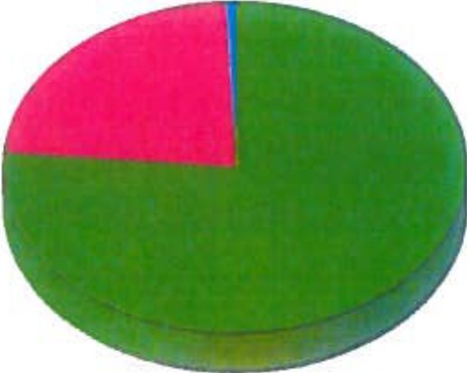Figure 5 (below) graphically presents the number of all lots created, both from major and minor subdivisions, from General Business zoning districts (0.7%), residential zoning districts (76.4%) and the General Agriculture zoning district (22.9%) in 2019.
Figure 5
New Lots Created in 2019

11Residential Lots

II Agricultural Lots

- General Business Lots I
I

10

